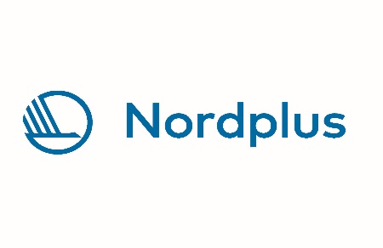

Good practices and ideas for international meetups at the library
During our Nordplus project “The library in a multilingual society” we explored ways to better service immigrants and get them into the library. One of the things we developed were weakly international meetups.
Here are ideas you can try out in your library for such meetups. We emphasized activities that we could do together that did not need language. We did all of these with both children and grownups, as some participants came with their kids, and sometimes the adults came alone, but all joined in.
This is how we advertised the meetups:
“Get Together meet-ups. The meetups are international meetings open to refugees, asylum-seekers, immigrants, and anyone seeking companionship. Whether you’re a family or an individual, you’re welcome to join us. Each week, we gather and do relaxing activities like painting, weaving, crafting, and more. It’s all about getting together, making new friends, and sharing stories in a warm, supportive space.”
We found that it is important to make sure that the space where the meetups were held were easy to find, so we made a sign that people could see as soon as they came in that showed which floor and which room the meetups were held in. Also, we always offered coffee and water, along with fruit and biscuits as food always brings people together.
To reach the immigrant groups we contacted various organizations working with immigrants, such as the Red Cross, and GETA society of immigrants and some embassies. We also contacted the towns officers working with immigrants and asked them to reach out to people contacting them. And lastly, we put an advert in various Facebook groups for immigrant groups, such as Venezuelans in Iceland, immigrants in Iceland etc.

Ideas for activities
Here is a manual for simple activities we tried out that worked well for us that you can try in your library.

1. Cardboard box city for kids
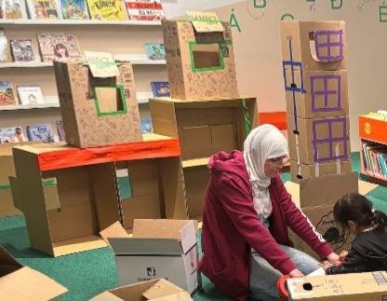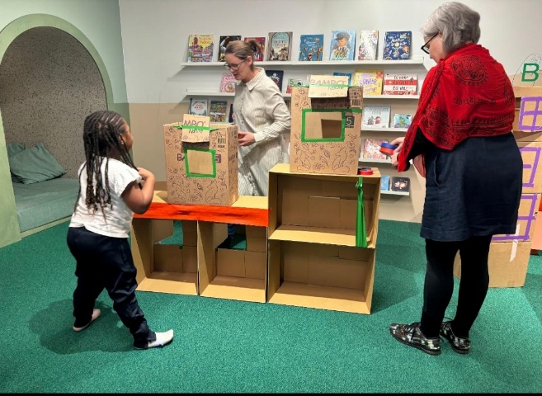

Materials needed:
1. Get bunch of cardboard boxes for free, for example at your local supermarket.
2: Colourful markers or crayons
3: Colourful tape.
4: Scissors

How to prepare:
Spread the cardboard boxes on the floor
Put the markers, tapes and scissors on a table

The workshop:
Invite the kids to use their imagination and make a house out of the cardboard boxes. Perhaps make one in advance to show possibilities. Let the kids play with their cardboard box city.

2. Perler beads activity
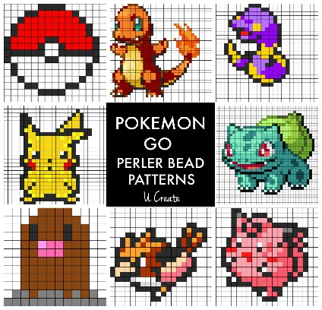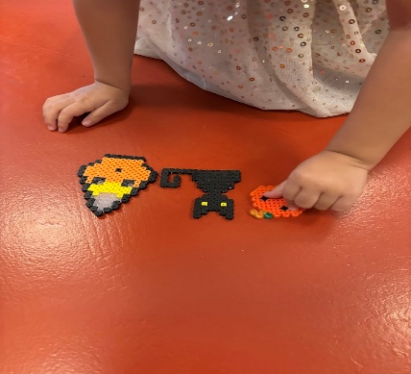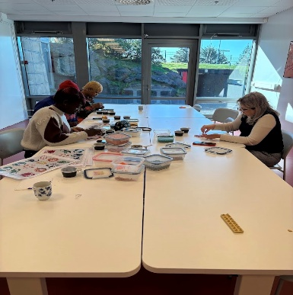

Materials needed:
1. Perler beads.
2. Iron and an ironing board.
3. Baking paper.
4. Print out Perler bead patterns from the internet. It is fun to have a theme. Like superhero theme, manga theme, Christmas theme, Halloween theme etc. depending on the time of year.

How to prepare:
Put the patterns on the table along with the beads. It is good to put the different colours in different plastic cups, so it is easer to find the right colour. Heat up the iron, but make sure no one can accidentally burn themselves on it, do not leave it unattended and hot.

The workshop:
Everyone chooses a pattern and starts making their own Perler beads pattern and once someone has finished a pattern help them iron it.

3. Origami workshop
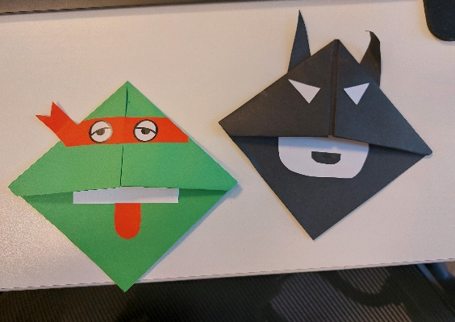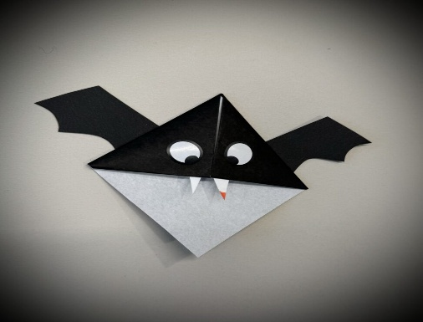

Material needed:
- Origami paper (thin paper) or normal paper in different colours.
- Print out simple origami folds, for example easy origami bookmark corner.
- Google eyes or eyes stickers
- Scissors
- Glue

How to prepare:
Put the printouts on the tables along with the materials. It can be fun to have a theme, for example a Halloween theme, superhero theme etc. Make a few examples beforehand to show the participants what are the possibilities.

The workshop:
Everyone starts with choosing which fold to make. Then they collect the materials for that fold and starts making origami.

4. Beautiful bodies - tapestry
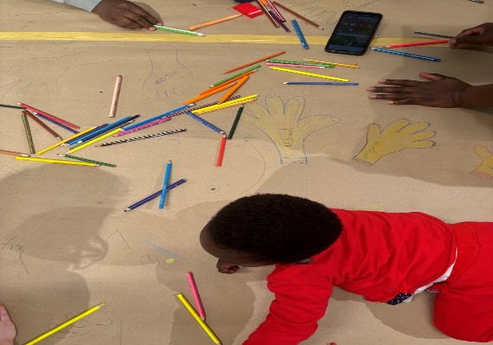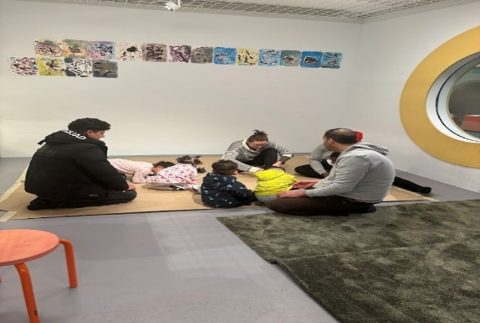

Material needed:
- Paper roll
- Tape
- Colours

How to prepare:
Clear a floor space. Roll the paper on the floor; to make it bigger, tape a few roll outs together. Have the colours ready.

The workshop:
The participants put their hands and feet on the paper and draw the outlines. Or they lay down on the paper and someone else draws the outlines of their entire body. Then participants colour the hands, feet and bodies in different colours. Good opportunity to talk about body image and how we are all unique and yet the same.

5. Mask-workshop:
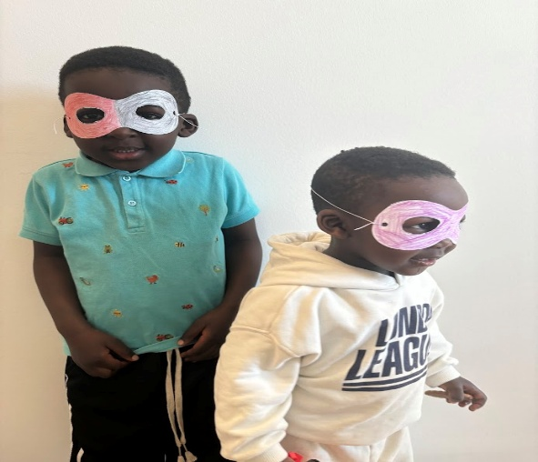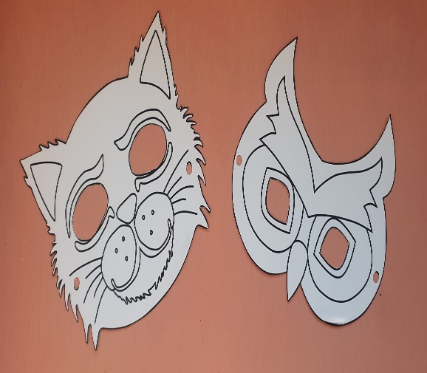

Materials needed:
- Thicker paper
- Printable masks (find on internet)
- Colours
- Elastic band suitable for masks
- Scissors
- Hole puncher
- Optional: Stickers, glitter, feathers, glues and other decorative materials

How to prepare:
Choose printable masks from the internet. Print them out on a thicker paper. Put them on the tables along with the material. Make one or two in advance to show the participants.

The workshop:
Let the participants choose their mask and colour them. It is better to colour or decorate them first, be for cutting them out as less colour will go on the table. Then they cut them out, use the hole puncher to make holes for the elastic band and then put on the mask. It can be fun to have a theme. Halloween masks, superhero masks etc.

6. Leaves and flowers art
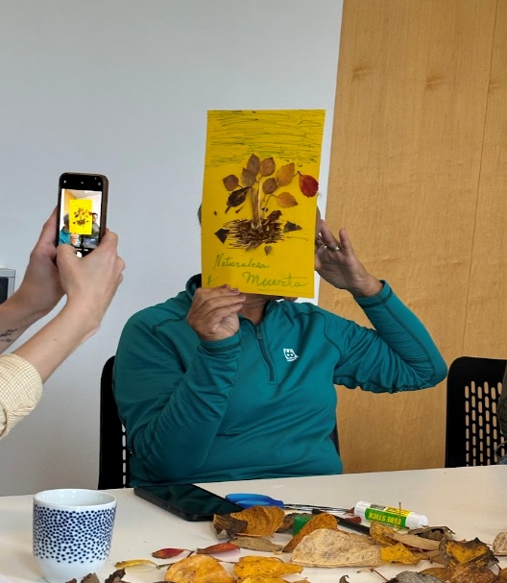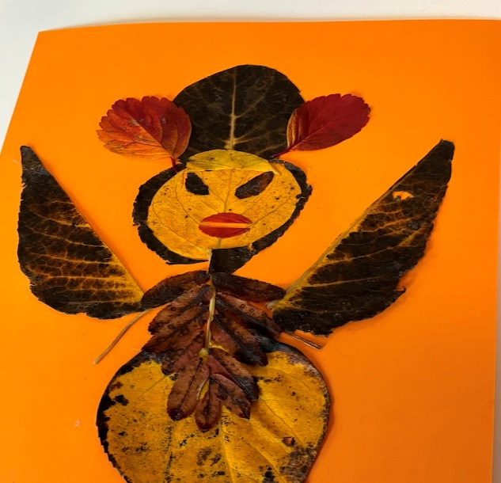

Materials:
- Leaves and flowers
- Glue
- Paper
- Markers

How to prepare:
Pic some leaves and flowers outside. Dry them, for example between newspaper pages. Then put the flowers and leaves on a table along with the other materials. Make one or two pictures in advance to show the participants.

The workshop:
Make pictures by gluing the leaves and flowers on the paper.

7. Yarn art
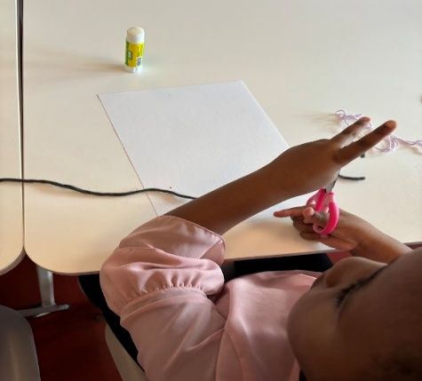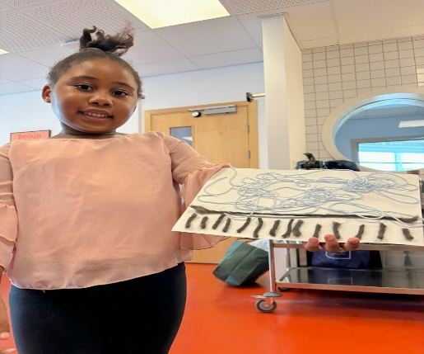

Materials:
- Yarn
- Glue
- Paper
- Colour

How to prepare:
Put out the yarn, the paper and the glue. Make one or two examples for people to see.

The workshop:
Create images by gluing the yarn on the paper and decorate with colour.

8. Collage art
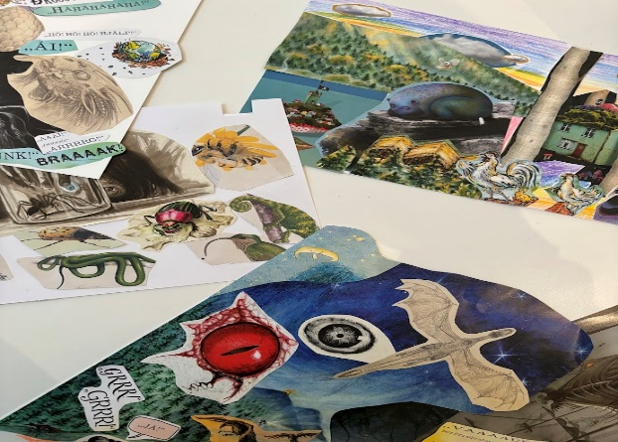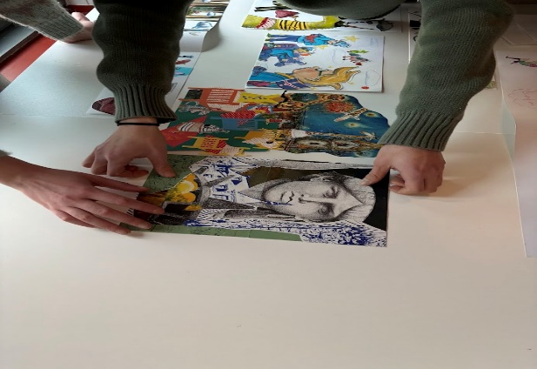

Materials:
- Paper
- Glue
- Scissors
- Old magazines, destroyed books, old pamphlets etc.

How to prepare:
Collect old magazines and destroyed books. Lay out the material. Make one picture beforehand as an example.

The workshop:
Let the participants cut out images from old magazines and destroyed books and glue them on a paper to make beautiful collages.

9. Watercolours
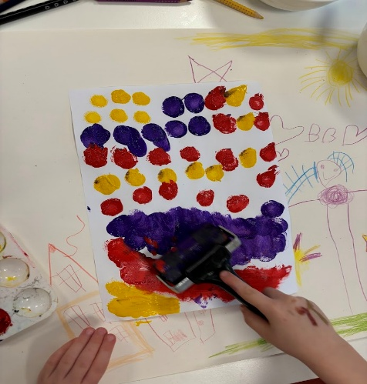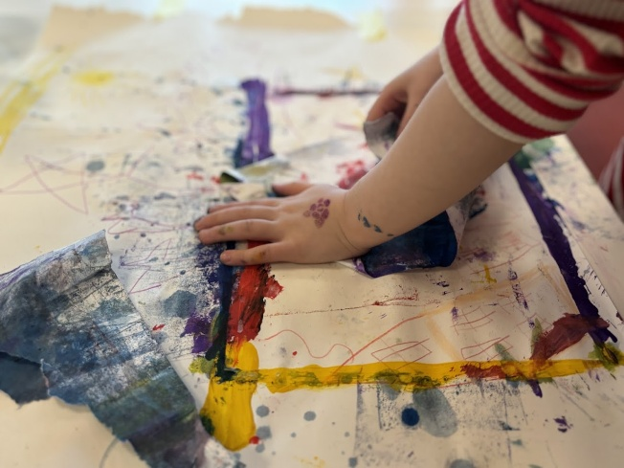

Materials:
- Watercolours
- Paper
- Brushes
- Paper cups for water
- Paper dishes for mixing colours

How to prepare:
Perhaps you want to put some kind of rubber tablecloth on the tables. Put water in cups and put out all the materials. If the participants are kids perhaps urge them to take of expensive sweaters or if you have protective aprons to use that. It is good to have a wet cloth available to clean stuff up immediately.

The workshop:
Let the participants paint pictures.

10. Flags of the world workshop
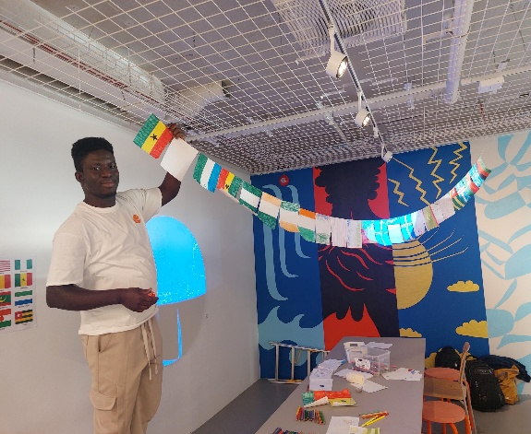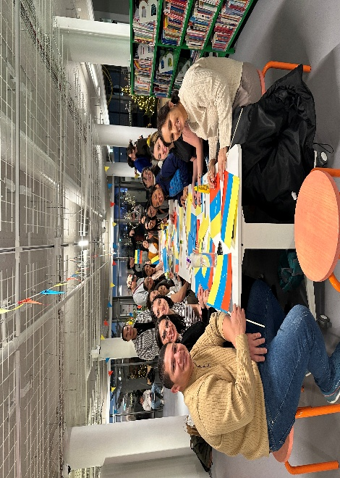

Materials:
- Paper, both white and in different colours
- Scissors
- Glue
- Colours
- Print out the different flags for people to see.
- A string

How to prepare:
Print out pictures of the flags so people will know how they look like and put them up on the walls or on the table. Put out the material. Decide on the theme. You can either have people just choose any flag to make from around the world, or if there is a theme, for example if you are celebrating African culture and want them to make African flags, or are having a south American festival and then they are just making south American flags, or perhaps that every one makes their own flag. Decide on a size for a flag so they are all the same size.

The workshop:
Let the people choose which flag each wants to make, and either make them on white paper and colour it or use colourful paper and cut and glue them together. When each flag is ready put them up on a string and hang them up to decorate the space afterwards.

