

Sensory story telling

As a way to help children with multilingual background to engage with stories and understand them better.

During our Nordplus project “The library in a multilingual society” we explored ways to better service immigrants. One of the things we developed were regular sensory story telling for children age 0-5 at the library.

We noticed that by using musical instruments, songs, puppets, lights, colours etc. to communicate to stories to the children it became easier for children who are new to the language, younger children and neurodivergent children to focus on the story and enjoy the story hour.

After we started these sensory story hours the number of immigrant children attending the story hour multiplied. And even though some did not understand any Icelandic they were able to enjoy the story. The use of repetition and rhythm also helped them learn words and is a great way to learn the language.

When we have decided on a story to read to the kids, we go through it and ask ourselves, are their words or sentences that are repeated that we can let the children say with us? Is there an opportunity to sing a song while telling this story? Is their something in the environment of the story that has strong colours that we can represent with fabric? Is there an opportunity to use puppets or teddy bears? What else can we do to communicate this story to the children via the senses?

Ideas for sensory story telling that you can try out in your library

- Spiral coil bound books

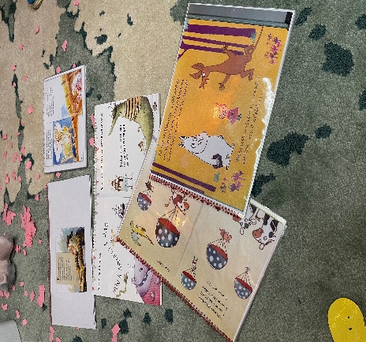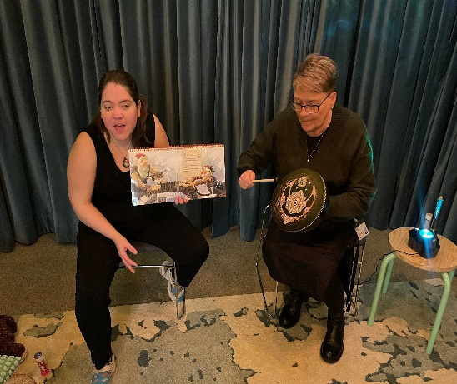

We took a few books and had them spiral coil bound, so that we could read on the page turning towards us, and the kids could at the same time see the pictures facing them. This way they could always see the photo, even when we were reading.

- A cozy space with no disturbance

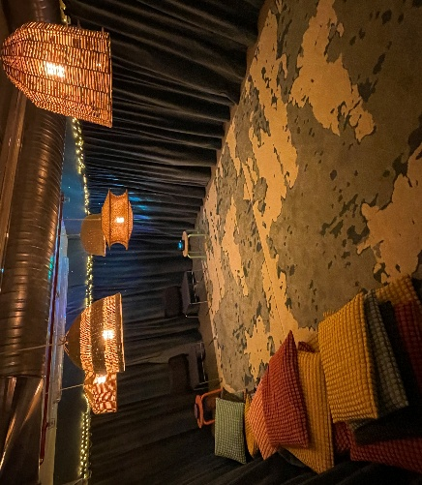

We developed a cozy space, with soft lighting. The kids take of their shoes before entering and they get their pillow and sit down. This way by entering the space they are already in the mindset for listening to a story. It is easier for them to focus and they relax.

- Musical instruments

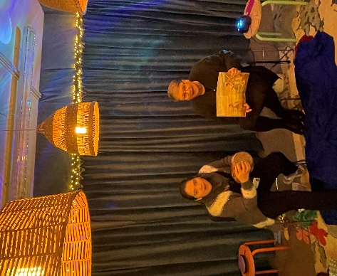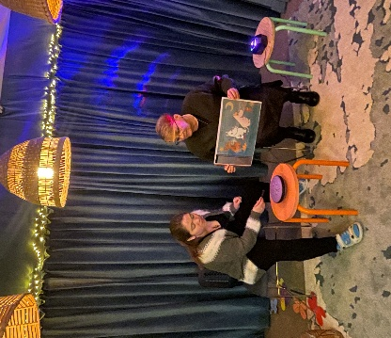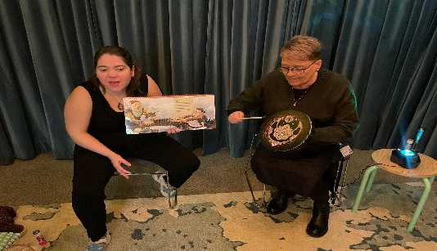

We use a variety of easy-to-use musical instruments. Neither one of us know how to play any musical instruments, so these were all things that anyone can use.
For example, we use a tongue drum at the beginning of each story, just to make some beautiful sounds and frame in the stories. We sometimes use an African drum to make a beat when someone is walking or running, and we use a shamanic drum as a beat under some stories or to make the sounds of waves in the ocean etc.

- Using fabric

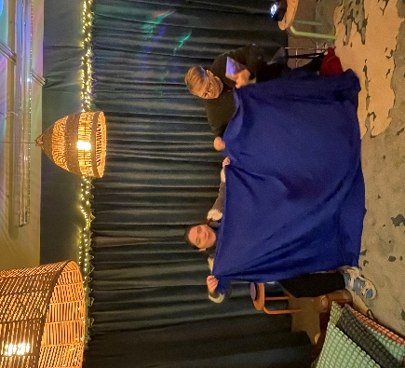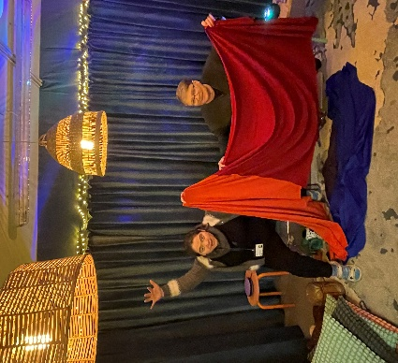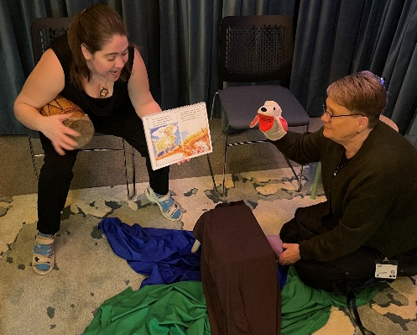

We often use colourful fabric to help us tell the story. It can represent the ocean, the sky, fire, the green, green gras etc. We chose a fabric that is easy to move and stretch to give it more potential.

- Using puppets and teddies

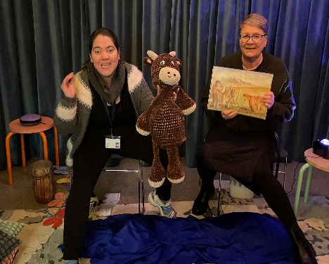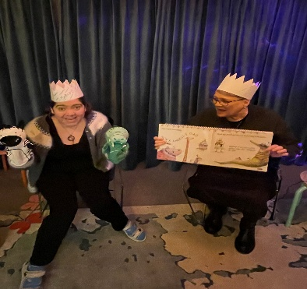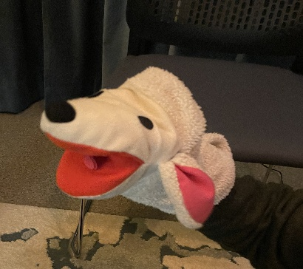

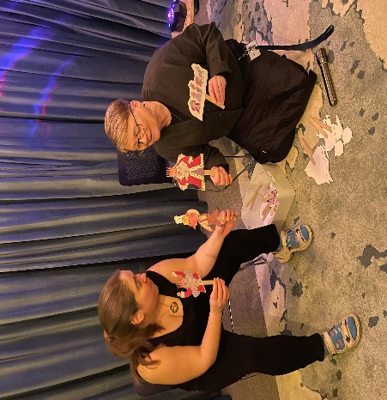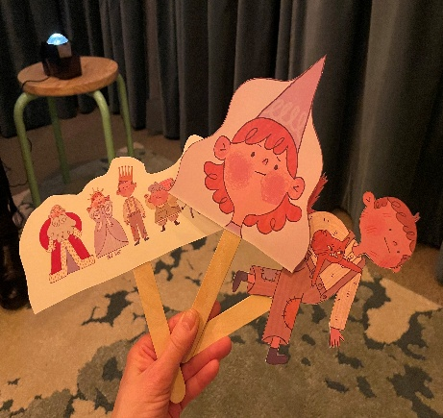

We use all sorts of puppets. We bought some hand puppets. We got a member of our library’s knitting group to knit for us a cow puppet for one of our fairytales. We got an artist who is working in our library to draw for us characters for one fairytale and then we made them into puppets using ice cream sticks. We try to do different things with different stories to keep it fresh for the kids.

- Shadow images

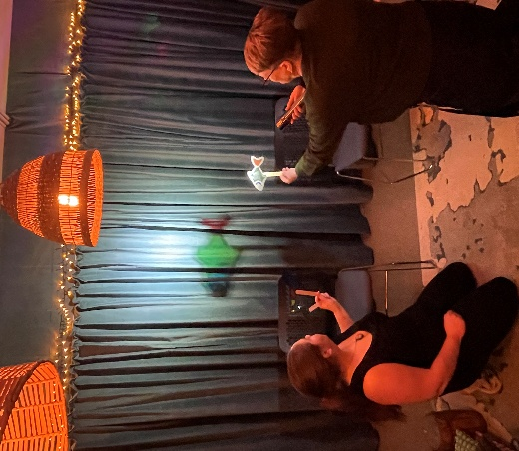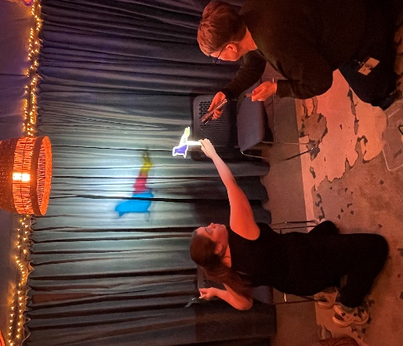

We have been playing with shadow images. One thing we did is we cut out some figures, bought coloured acrylic sheets and glued them into the figures. Then we used a flashlight to make the figures come a life on our fabric wall. This made for a great story hour for a story under the sea.

- Mobile images, cut outs

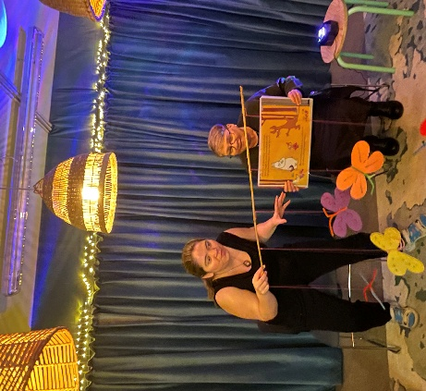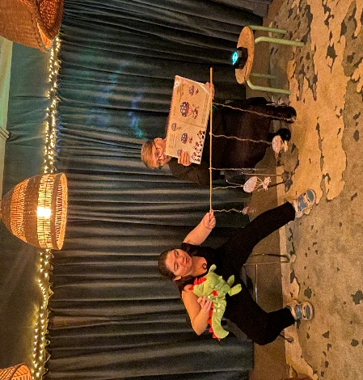

We created our own mobile images, butterflies that we tight to a stick so the butterflies could fly above the heads of the children. And animals in parachutes etc. Easy to make, just cut out images, we had them plastered so they would last longer, tied them to a string and stuck them to a stick. Kids really loved them, especially the butterflies.

- A light projector

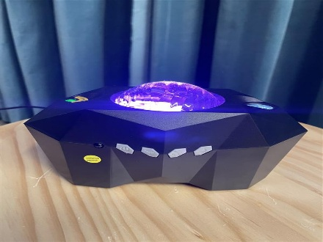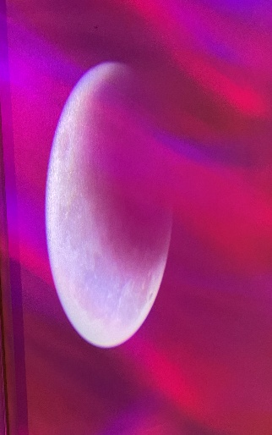

We bought a light projector, and we have used it during a few stories. In one Moomin story the characters are going on a moon walk. We had a fabric over the projector and then revealed the moon at the right moment; the kids were so excited when the moon appeared suddenly. We also used the northern light projection both as northern lights, but also to create atmosphere when we were doing the under the sea story.

- Bubbles, balloons and paper cut outs

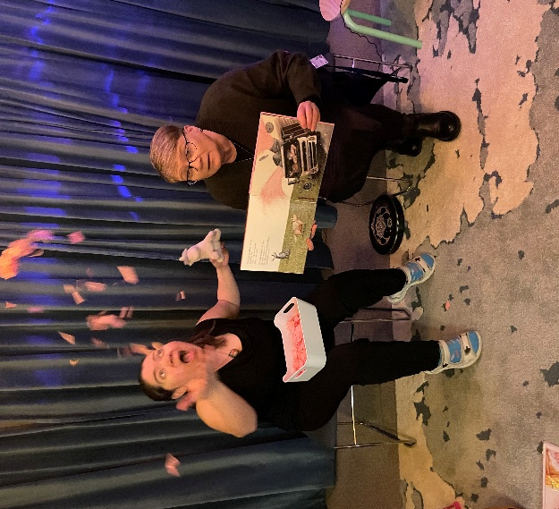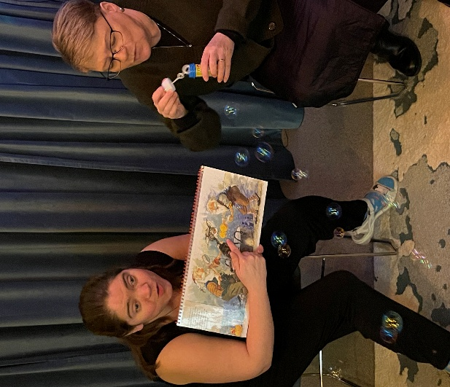

We often use bubbles, as kids love them. We used them when a character took a bath to show the soap everywhere. And during a birthday party to represent balloons. And when there is a victory for the character or any kind of celebration. They are going to want to burst them, so we just take a moment and let them, and then we stop with the bubbles and continue with the story. We also cut up coloured paper into tiny pieces and threw them in the air like confetti. We did this for example in one story when pink paint fell over a horse making him pink and then the pink paper rained over the kids. They loved it and helped us throw it again in the air for a while before continuing the story.

- Songs, sounds, poems and repetitions

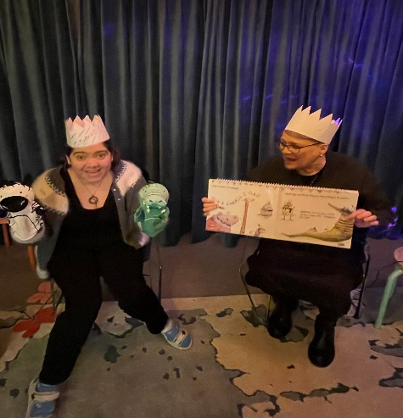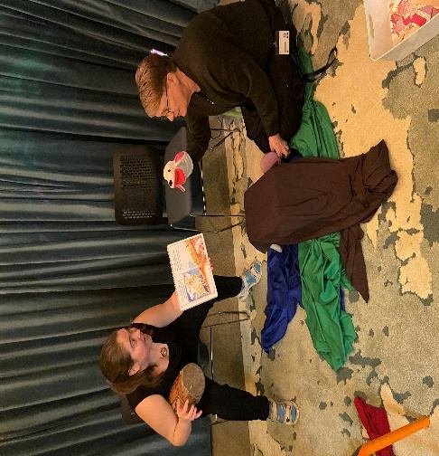

We use every opportunity to get the kids to sing songs with us that everyone knows. In one story were there is a birthday party, we put on birthday crowns (some countries have birthday hats instead) and got the kids to sing the birthday song to the character whose birthday it was. We also went over a list of songs that every kid in our country knows, like the butterfly song (Fljúga hvítu fiðrildin) that we sing when we use the butterfly mobile stick, and the songs of the colours etc.

We also use nursery rhymes, for example in Iceland we have a nursery rhyme that you say when you finish a story, so we always end with that (Köttur út í mýri…)

And when a line is repeated again and again in a story, we get the kids to say them with us. For example, in the fairytale the three goats, the troll always says: “who is stomping on my bridge!” and we ask the kids to say it with us with their troll voice.

Also, we make them do sounds with us and play out scenes. So, for example when a character goes to a trampoline, we will say, what sound does it make when you jump on a trampoline and then we make the sound. Or we will say, what sound does the cat make and then we make it with them.

- Movements

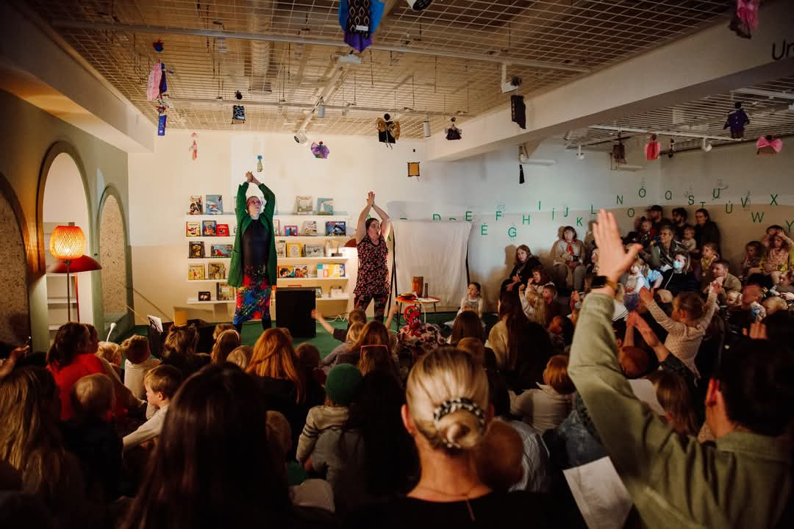

We use some movements with the kids. If it is raining, we do the rain with our fingers and get the kids to it with us. We get them to make butterflies with their hands and play butterflies, and we get them to make a forest by all putting their hands in the air to represent all the trees.

Good luck with your sensory story hour and don’t be afraid to try out new things!

